The Smart Way to Use iPads in the Classroom

It’s not about the games or educational apps.
By Lisa Guernsey|Posted Monday, April 15, 2013, at 10:51 A
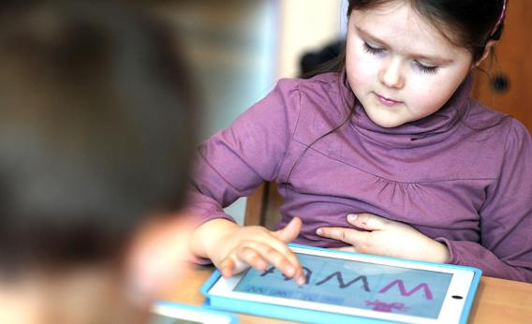
Can American public schools learn to use iPads and other touch-screen technology in a meaningful way?
Photo by Frederick Florin/Getty Images
Touch-screen tablets for young students have become all the rage. Some districts are even buying iPads for every kindergartner, a move sparking both celebration andconsternation. Do we really want to give $500 devices to kids who can’t even tie their shoes? What are these schools doing with these devices, anyway?
Last month, I had a rare opportunity to ask those questions at a school in Zurich, Switzerland. As part of a tour to talk about my book, Screen Time, I was treated to three days of visits to nearly a dozen classrooms at the Zurich International School, a private school that caters to English-speaking immigrants and expats whose companies have brought them to this exquisite city near the Alps.
ZIS, as the school is called, has distributed 600 iPads—one to every student in first through eighth grades, plus a set for teachers in preschool and kindergarten to use with children in small groups. And I had only one thought when I arrived: This is a school with money. In my first few minutes of walking through its colorful, light-filled hallways and well-stocked libraries, I figured I would be leaving Switzerland rich in chocolate but poor in insights that could have any bearing on public education in the United States.
Advertisement
I was wrong. Not about the money—ZIS has resources public-school teachers could scarcely dream of—but about the lessons I might bring home to generate smarter conversations about using tablets in the classroom.
The school has an unconventional take on the iPad’s purpose. The devices are not really valued as portable screens or mobile gaming devices. Teachers I talked to seemed uninterested, almost dismissive, of animations and gamelike apps. Instead, the tablets were intended to be used as video cameras, audio recorders, and multimedia notebooks of individual students’ creations. The teachers cared most about how the devices could capture moments that told stories about their students’ experiences in school. Instead of focusing on what was coming out of the iPad, they were focused on what was going into it.
One morning I watched first-graders taking assessments of what they understood about “systems.” No pen-and-paper test was in sight. Instead, the teacher asked her students to come up with an example of a system and record a video of themselves explaining why their choice did, in fact, represent a system. A girl with a blond braid had drawn pictures of how people check out library books. With some technical guidance from the aide sitting next to her, and using an app called Explain Everything, she started arranging the pictures in a digital flow chart, adding arrows between her drawings of the book shelves, the checkout counter, the book at home, and the book being returned to the library. A few minutes later, she sat in a quiet corner by herself, pressed the record button, and explained each picture out loud. “My system is good,” she said at the end, “because if you don’t do something in my system, it will break down.”
Sam Ross, a second-grade teacher at ZIS, sees real potential in moments like this. “Children are being able to show what’s in their minds by adding the oral explanation,” he said. “That’s off-the-charts amazing.” Particularly helpful, he said, is to watch the recordings made by young children and English-language learners—students who may not speak up much in class but can actually show deep learning when asked to interview each other or record what they know. But most eye-opening, he said, is watching children have their own “aha” moments after watching recordings of themselves and talking to teachers about what they were thinking at the time.
At ZIS, every student has a blog or, in the case of younger children, a digital portfolio that teachers maintain. These portfolios allow teachers (as well as parents and students) to review specific work and rewatch moments that exemplify how the children have progressed over the year. One teacher showed me the blog of a fifth-grade girl who had recorded an assignment to show her knowledge of the parts of a plant. She did so by recording herself teaching a first-grader and answering the first-grader’s questions. In P.E., fourth-graders have recorded gymnastics routines so they can watch what they looked like and decide how to improve.
The iPad rollout, which began in earnest at the start of this school year, launched only after Mark Dilworth, director of education technology, consulted with teams of teachers in each grade to determine what they needed. Before students received their tablets, teachers experimented with video tools and chose appropriate apps. Every student’s device features the same apps—all downloaded by the information technology staff. Most of the apps on the iPads for the lower grades are aimed at creating and expressing ideas. In addition to Explain Everything, they include MyStory, iMovie, Animation HD, Google Earth, Book Creator, Show Me, Brushes, and Comic Life. They also feature Follett Reader and Overdrive, two subscription-based services to digital book collections.
This notion of using the iPad to make learning visible is not without hiccups, however—particularly when it comes to filming and editing. Despite all the talk about kids being “digital natives” who can navigate iPads before they can walk, teaching children to create videos isn’t easy. When I watched the first-graders complete their assessment on systems, one girl’s videos wouldn't save at first—a technical problem that could have dissolved into a meltdown if a teacher had not been sitting right next to her to help. “It gave me gray hairs,” said a first-grade teacher about those first few weeks teaching iMovie to 6-year-olds. But she quickly added that the extra time was worth it.
Would teachers in American schools with less flexibility be able to carve out that kind of time when under pressure to finish a unit or prepare for a state test? Would children be surrounded by teachers who encouraged them to create their own logs of learning?
Ten years ago, Stanford’s Larry Cuban noted that computers in the classroom were beingoversold and underused. In short order, the iPad craze could take the same turn. My lesson from ZIS is that we should make sure we have teachers who understand how to help children learn from the technology before throwing a lot of money into iPad purchasing. It wasn’t the 600 iPads that were so impressive— it was the mindset of a teaching staff devoted to giving students time for creation and reflection. Are American public schools ready to recognize that it’s the adults and students around the iPads, not just the iPads themselves, that require some real attention?
This article arises from Future Tense, a collaboration among Arizona State University, the New America Foundation, and Slate. Future Tense explores the ways emerging technologies affect society, policy, and culture. To read more, visit the Future Tense blog and the Future Tense home page. You can also follow us on Twitter.

